External Funding
Farndon Community Trust would like to thank the European Fund for Rural Development for its support in allocating us a grant towards the refurbishment of the kitchen at Farndon Community Club. Thanks to their support we now have a newly kitted out and operational kitchen at the Club which can be booked for catering at private events and will also allow a wider variety of Club events to be offered. This will help with our continued fund raising to allow an ongoing improvement plan of Club facilities.
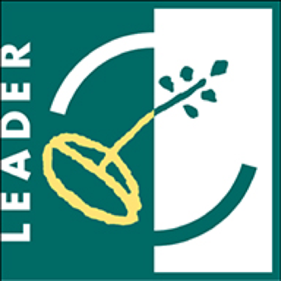

The European Agricultural Fund for Rural Development:

Europe investing in rural areas

